7 Clear Indicators Your Business Needs a Virtual Assistant

Virtual Assistants can turn tough situations into big wins, helping tired staff handle heavy workloads.
7 Indicators Your Business Needs a Virtual Assistant
Does your business have ambitious goals for the year, aiming to boost revenue and secure success? The growth journey, while exciting, often brings additional responsibilities for your existing staff. Workloads skyrocket, teams reach their limits, and employees may start showing signs of burnout.
In such demanding times, savvy business owners recognize the advantages of bringing in a Virtual Assistant (VA) for crucial support.
Curious if a Virtual Assistant is the missing piece in your business puzzle? Here are seven clues pointing to the fact that 2023 might just be the perfect time to consider hiring a VA:

The Need for Virtual Assistance
Seven Indicators for Hiring a Virtual Assistant in 2023
1 – Are Boring Tasks Taking Up Too Much Time?
If you’re a business owner and feel stuck doing the same old tasks, wouldn’t it be nice to focus on the important stuff?
We know running things can get overwhelming. But here’s the scoop: focus on the big, important stuff that moves your business forward. The problem is, that your day is filled with all sorts of tasks.
Here’s a trick: do what you’re great at, and let others handle the rest. Keep time for those super important talks about where your business is heading. And if something is slowing you down, why not let someone else deal with it?
The Virtual Assistants tackle everyday tasks, leaving you free to steer your business towards success. It’s like having a secret weapon for your business!
7 Indicators Your Business Needs a Virtual Assistant
2 – Does Your Team Need Special Skills for Growth?
As your business grows, do you find yourself needing new skills?
Expanding your business means you might need some special skills. Are you a small business owner or just starting out? Well, you’re not alone. Lots of small business leaders, like you, often change their game plan to grab new chances. You’re always tweaking your products or services based on what your clients say and what’s happening in the industry.
Now, chasing the money is a great way to succeed in business. But it can also throw your team into some unknown areas. Suddenly, you might need to set up an Amazon store, use new technology, or plan out your social media posts.
Before committing to hiring a new employee for these specialized needs, consider a Virtual Assistant. These VAs are often pros with special skills that can match up with all the growing needs of your business.
3 – Does Your Customer Service Need a Boost?
Think about how your customers experience your business online. Does it feel slow or outdated?
Let’s talk speed. How fast a brand responds and how good the help is—they’re like report cards for a good or bad experience. And we all know happy customers mean more sales.
Now, think about the first time someone becomes your customer—how’s that experience? Do they feel taken care of every step of the way? Giving awesome service at every step helps you build long-term relationships. That means more repeat purchases, renewals, and even 5-star reviews and referrals. It puts your business right at the top.
Here are two questions for you:
- Is my team quick enough to respond to emails, chats, calls, and social messages?
- Is my process for bringing in new clients straightforward, so they feel super valued?
If you’re not jumping up with a big “Yes!” to both, maybe a Virtual Assistant is just what you need.
A trained Virtual Assistant can:
- Answer social media messages
- Pick up phone calls
- Create super clear steps for bringing in new clients
7 Indicators Your Business Needs a Virtual Assistant
4 – Feeling Lost in the World of Online Marketing?
Creating content is crucial for grabbing your customers’ attention and generating leads. But keeping up with it all can feel like a big challenge. You’ve got your Facebook, Instagram, and TikTok profiles sorted, but now what? What to post, and how to get more people to see, like, and share your content daily?
If the stress of realizing you haven’t posted in ages sounds familiar, it might be time for a solution. Enter the Virtual Assistant (VA). They bring the consistency your business needs to turn your content plans into action, ensuring your awesome ideas reach your audience regularly. They’re like your trusty sidekick in the content creation journey.
5 –Are You Losing Opportunities?
One of the biggest blunders companies make is waiting too long to follow up. If you’re not keeping tabs on new leads, you’re basically saying goodbye to potential customers, sales, and money.
Imagine this: someone needs your services urgently, but if you wait too long, they’ll go elsewhere. Act fast, reach out to new leads quickly, and you’ll boost your chances of turning them into happy customers.
But it’s not just about new folks. Don’t forget your existing opportunities. Keep the conversation alive, build trust, and you might snag repeat sales and referrals.
Now, here’s the superhero move—introduce a Virtual Assistant (VA). They’re like your follow-up wingman, making sure no lead gets left behind. With a VA handling the outreach, you can focus on rocking other aspects of your business.
6 –Is Your Tech Not Doing Enough?
How sure are you that your data is spot-on and fresh? Picture your CRM like a superhero tool. Do all the company and contact records have the stuff that really matters for your business?
Imagine dialing the wrong number or emailing an old address—total productivity bummer, right? Messy data messes up your reports and stops you from making awesome goals for your business and cash flow.
Now, here’s where the hero, the Virtual Assistant (VA), steps in. They join your squad to put in, check, and update all your records. With a VA on your side, your reports will tell the real story about your business. No more data drama!
7 – Is Your Team Stuck in a Fixed Schedule?
Ever wished you had a video wizard for three days a week in the US Pacific Time Zone? Or maybe someone to handle calls from midnight to 5:00 am in Eastern Europe? Finding a regular worker for these gigs? Tough, maybe even impossible.
See, regular workers usually live close to where they work, stick to one time zone, and do the 9-to-5 thing.
Now, enter the Virtual Assistant (VA) hero. You can snag a VA who is capable of adapting to any work schedule, and location and is even specifically trained for the unique needs of your business.
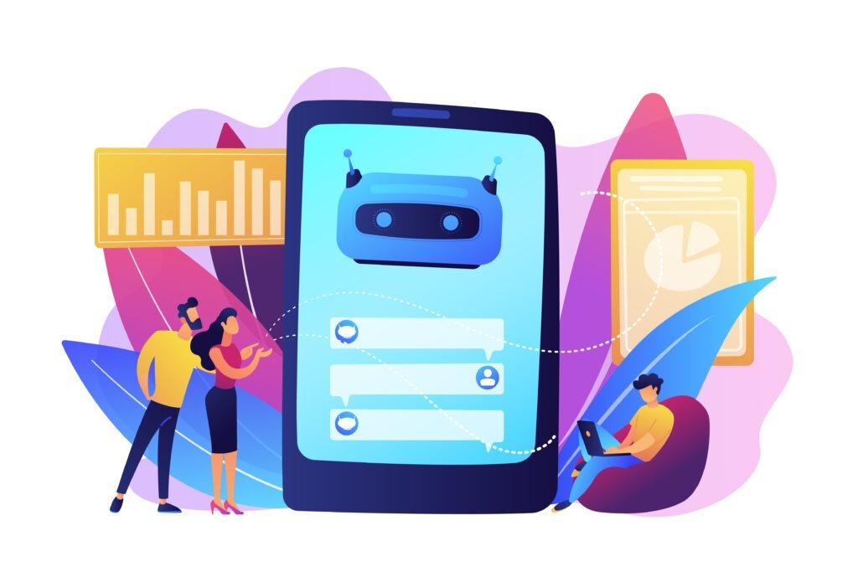7 Indicators Your Business Needs a Virtual Assistant

Start Your Virtual Assistant Journey
If these questions make you curious, it might be time to try a Virtual Assistant for your business in 2023. It’s easy:
- Write down the skills you need on our website.
- Meet candidates who are already checked and ready to go.
- Take back control of your day while we handle schedules and payroll.
Seize the chance to make your business even better. Dive into the world of Virtual Assistants today. Let us know what you need, and we’ll help you find the perfect match. Transform the way you work and see your business grow like never before.

Conclusion
In summary, adopting Virtual Assistants is a strategic move for businesses facing the challenges of growth, aiming to enhance efficiency and leverage specialized skills. Recognizing the signs that indicate the need for a Virtual Assistant is crucial in navigating the intricate landscape of business operations.
From managing mundane tasks to addressing gaps in customer service and digital marketing, Virtual Assistants emerge as versatile partners in the pursuit of sustained business success.
Take the first step to hire a Virtual Assistant today and let us know what skills you need.

